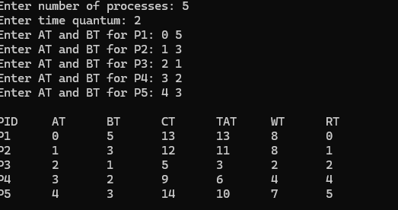

#include <stdio.h>

int main() {
int n, tq;

printf("Enter number of processes: ");
scanf("%d", &n);

printf("Enter time quantum: ");
scanf("%d", &tq);

int pid[n], at[n], bt[n], rt[n];
int ct[n], tat[n], wt[n], response[n];
int queue[100];
int front = 0, rear = 0;

int visited[n], started[n];

for(int i = 0; i < n; i++) {
pid[i] = i + 1;

printf("Enter AT and BT for P%d: ", pid[i]);
scanf("%d %d", &at[i], &bt[i]);

rt[i] = bt[i];
visited[i] = 0;
started[i] = 0;
}

int current_time = 0;
int completed = 0;

while(completed < n) {

for(int i = 0; i < n; i++) {
if(at[i] <= current_time && visited[i] == 0) {
queue[rear++] = i;
visited[i] = 1;
}
}

if(front == rear) {
current_time++;
continue;
}

int i = queue[front++];

if(started[i] == 0) {
response[i] = current_time - at[i];
started[i] = 1;
}

if(rt[i] > tq) {
current_time += tq;
rt[i] -= tq;

for(int j = 0; j < n; j++) {
if(at[j] <= current_time && visited[j] == 0) {
queue[rear++] = j;
visited[j] = 1;
}
}

queue[rear++] = i;
}
else {
current_time += rt[i];
ct[i] = current_time;

tat[i] = ct[i] - at[i];
wt[i] = tat[i] - bt[i];

rt[i] = 0;
completed++;

for(int j = 0; j < n; j++) {
if(at[j] <= current_time && visited[j] == 0) {
queue[rear++] = j;
visited[j] = 1;
}
}
}
}

printf("\nPID\tAT\tBT\tCT\tTAT\tWT\tRT\n");

for(int i = 0; i < n; i++) {
printf("P%d\t%d\t%d\t%d\t%d\t%d\t%d\n",
pid[i], at[i], bt[i], ct[i], tat[i], wt[i], response[i]);
}

return 0;
}

